
phgy311
lecture #: | date: | professor:
21 | November 1, 2006 | Dr. Haghighi
announcements:
Good Luck on the quiz!!

Please Note: This Lecture is UNEDITED. The edited version will be available after the quiz.
set #7a
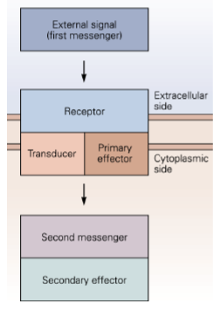
Synaptic integration and modulation, and the role of metabotropic receptors in synaptic responses
- metabotropic receptors could be at any synapse
- depending on the site of metabotropic receptor action, there can be different consequences
- In general, the different metabotropic receptors share a basic, common molecular logic: the response of metabotropic receptors is an increase in secondary messengers.

Different Metabotropic Receptor Systems
- cAMP system
- Primary messenger activates the β-adrenergic receptor, which activates G_{s}, which activates adenylyl cyclase.
- cAMP levels in the cell increases, which activates cAMP-dependent protein kinase (aka. PKA). An increase in PKA could increase phosphorylation of ion channels, affecting membrane properties.
- Phosphoinositol system → see “Muscarinic ACh receptors” later in this lecture
- Arachidonic acid system → see “Histamine receptors” later in this lecture
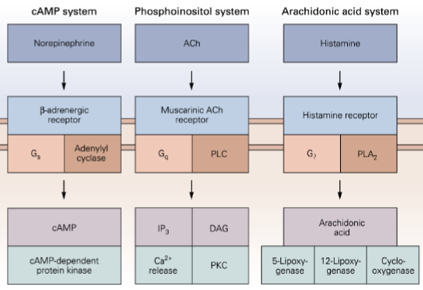

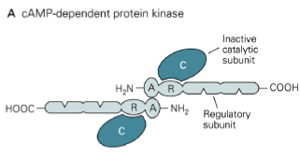
There are several families of protein kinases
- cAMP-dependent protein kinase (aka. PKA)
- This is just a small family of the protein kinases, but we look at them because they generally require a secondary messenger to be activated, which are characteristic of metabotropic receptors.
- cGMP-dependent protein kinase
- Protein kinase C
- See later on in the lecture regarding muscarinic receptors
- Ca²⁺/calmodulin-dependent protein kinase
- Especially important for long-term synaptic modulation (aka. long-term synaptic plasticity/ potentiation).
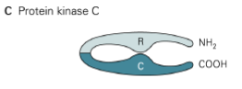
- A multi-subunit kinase
- Upon increase in intracellular Ca²⁺ concentration, Ca²⁺ binds and activates calmodulin, calmodulin binds and calmodulin-dependent protein kinase.
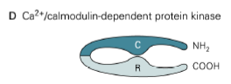
- Upon activation, calmodulin-dependent protein kinase auto-phosphorylates and becomes Ca²⁺-independent. It stays activated for potential long-term effects.
- It phosphorylates downstream effectors, which could be ion channels, or downstream signaling molecules for regulation of gene transcription.
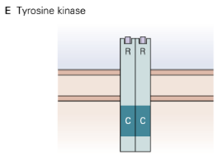
- Tyrosine receptors
- Different from PKA and other kinases because these are directly activated (they are NT receptors with extracellular regulatory domains), and auto-phosphorylate (kinase activity, intracellular catalytic domain,).

Note: Activation of ionotropic/metabotropic receptors can turn on secondary messengers, which can turn on kinases and have short term effects (e.g. affect receptors or ion channels), or long term effects (i.e. affect gene transcription through transcription factors in a downstream cascade).

Phosphorylation of ACh receptors can lead to increased desensitization
- Simple explanation of desensitization: closure of receptor, or decrease in response of receptor to transmitter.
- If receptors are desensitized, the EPSPs will be smaller in either amplitude or duration.
  - Question to class: What is the underlying cause of desensitization at a macroscopic level?
Student responses: Change in ACh receptor site, or decreease in probability of ACh binding? Phosphorylation affects sensitivity of receptor to ACh because it changes the binding site conformation?
Dr. Haghighi’s response: These are good guesses, but it does not affect ACh binding because phosphorylation of the receptor occurs intracellularly.
- Macroscopically, on an I vs. time graph showing the current change due to the opening of single ion channels in a patch clamp, the number of opening channels observed would decrease.
- Desensitization is a kinetic term. It affects the gating of ACh receptors by shortening the duration of the single channel opening.
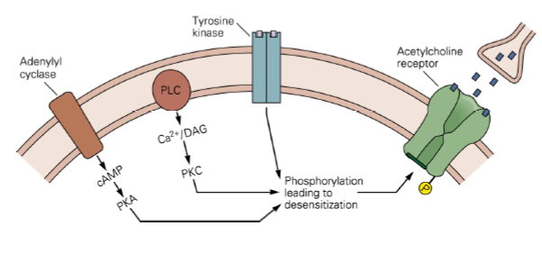
- The conductance of the single channel due to desensitization has not changed, but the probability of its opening has changed. For the sake of this course, we say that desensitization affects the mean-opening time and the probability of the ion channels, both individually and as a population of ion channels. (These two are hard to distinguish.)

- Student Question: If the ACh did not stick to the ion channel receptor, wouldn’t that also decrease the opening time?
- Dr. Haghighi’s response: Yes, but it gets a little more complicated. If a ligament binds to the receptor, it will open, but its kinetics can be affected if the sensitization of the receptor changes. Upon long term exposure of a receptor to NT, it becomes desensitized and no longer opens. Once a receptor is bound to the NT (neurotransmitter), it can be now considered NT-independent. But desensitization causes a shortening of the channel opening time.

- Student Question: Some V-gated receptors are inactivated by a molecule blocking the channel. Is that what happens here?
- Dr. Haghighi’s response: No. Think about probability of the channels opening.
  - Single channels don’t open for a long period of time; if the probability of one single channel opening is decreased, the probability of two channels coincidentally opening is also decreased. K+ channels generally open for a long time.

- Student Question: If the ACh is not chewed up, would the end result be a longer EPSP?
- Dr. Haghighi’s response: Yes.

- Student Question: How do auto-phosphorylated kinases (e.g. Ca/calmodulin-dependent kinases) turn OFF?
- Dr. Haghighi’s response: Lots of mechanisms are known, these include phophatases and unknown protein-protein interactions. They don’t stay on forever. “Long-term effects” refers to 20-30 minutes following change in intracellular calcium concentrations. (See last part of lecture)

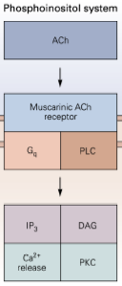
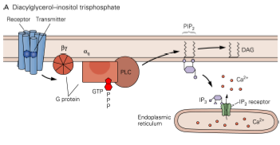
Muscarinic receptors activate PKC
- Note that while both nicotinic and muscarinic receptors are activated by ACh, nicotinic are ionotropic whereas muscarinic are metabotropic.
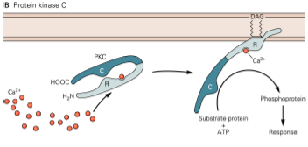
Upon activation of the muscarinic receptor, hydrolysis of phospholipids initiates 3 secondary messenger cascades:
- G-coupled protein receptor is activated, which activates PLC (phospholipase C).
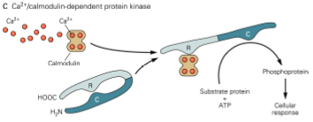
- PLC hydrolyzes phospholipids, namely PIP₂, which produces IP₃ and DAG, two secondary messengers.
- IP₃ (second messenger #1) activates intracellular calcium release from the endoplasmic reticulum. Calcium becomes the third secondary messenger. (Note: Of these 3 secondary messengers, Ca²⁺ is most involved in other cascades.)
- DAG (second messenger #2) is membrane-bound. PKC binds to DAG to be activated. Some isoforms of PKC also require Ca2+ for activation, but the critical step is PKC binding to DAG.
- The activated PKC can now phosphorylate substrates in ATP-dependent reactions.
- Calcium (second messenger #3) binds and activates calmodulin. Calmodulin then binds to the regulatory subunit of calcium/calmodulin-dependent protein kinase and activates it.
- Remember that Ca/calmodulin-dependent protein kinase is a multi-subunit protein (not shown in diagram). They can phosphorylate other substrates as well as auto-phosphorylate, making itself calcium-independent for long-term effects.
- As you can see, muscarinic receptor activation can lead to a lot of cascade changes in the cell.

Histamine receptors produce arachidonic acid
- The arachidonic acid system also involves a G-protein cascade.
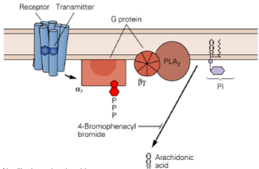
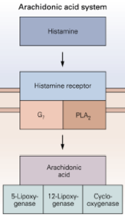
- Histamine binds to its receptor, which activates a G-protein cascade, which activates PLA₂ (phospholipase A₂).
- PLA₂ hydrolyzes PI (phophatidylinositol), producing arachidonic acid, which leads to a lot of cascades.
- Don’t worry how metabolites are produced. Dr. Farookhi will talk about the role of arachidonic acid in cellular response.

Muscarinic receptors
- A good place to look at muscarinic receptors is at autonomic ganglion synapses, where both ionotropic nicotinic and metabotropic muscarinic receptors are present.
[Figure A]
- Recording EPSP from there, you observe a fast EPSP and slow EPSP.
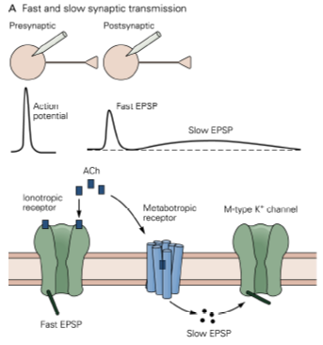
- Slow EPSPs are smaller in amplitude but longer in duration than fast EPSPs.
- Slow EPSP are due to the activation of muscarinic ACh receptors; fast EPSPs are due to the activation of nicotinic ACh receptors.
[Figure B] Shows the effect of muscarine on K current
- Muscarinic receptors, through secondary messengers, close M-type K⁺ channels (or lowers the probability of the M-type channels from opening).
- The closure of the M-type K⁺ channel leads to the generation of the slow EPSP:
- When M-type channels close, outward K⁺ flow is decreased.
- Continual small Na⁺ influx leads to net inward current (depolarization).
- Depolarization continues until the decrease in K⁺ conductance (due to M-type channel closure) is offset by increase in outward K⁺ driving force (due to influx of Na⁺). Equilibrium is reached when I_{K,out} = I_{Na,in} once again.
- What are muscarinic receptors good for? The slow depolarizing current caused by muscarinic receptors increases the cell’s excitability.

[Figure C] Shows the effect of a cell before and after the closure of M-type K⁺ channels
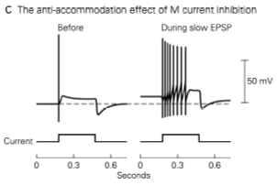
- Here, cells are stimulated by injecting current. In normal conditions, if no muscarinic receptors are activated (i.e. M-type K⁺ channels remain open), an autonomic neuron will fire only once, even in response to rapid pre-synaptic stimulation. The K⁺ current stops the cell from firing any more than that. If muscarinic receptors are active, the K⁺ channels are closed, then the cell can fire a lot more. Since muscarinic receptors cause a slow depolarizing current, the cell is much more excitable.

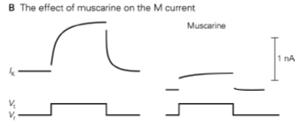

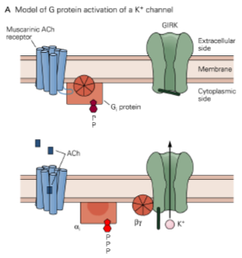
Muscarinic receptors are also involved in the direct activation of another type of K⁺ channel for inward K⁺ flow
- [Fig. A] G protein-coupled, inward-rectifying K⁺ (GIRK) channels are directly activated by G-proteins.
- Doesn’t require a secondary messenger, but requires close physical distance between muscarinic receptor and K⁺ channel.
- In the previous mechanism involving secondary messengers, we could experimentally inject a cell with a secondary messenger and get a response in a patch. Here, we would have to catch the muscarinic receptor WITH the K⁺ channel in a patch inside pipette to get a response.
- The G-protein must interact directly with the K⁺ channel to activate it.
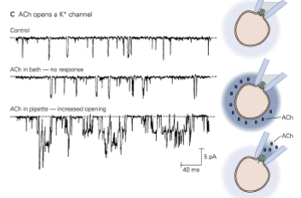
- [Fig. C] The patch clamp experiments here show that a cell bathing in ACh solution outside of pipette has no effect on the opening/closing of the GIRK (middle graph). If ACh was present inside the pipette, then channels were activated. Note that the [K⁺] inside the patch pipette was very high in this experiment, hence an inward K⁺ current is possible. Ion channels are dependent on the concentration gradient.
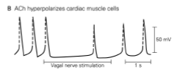
- [Fig. B] Muscarinic receptors are present on the heart muscles.
- By giving rise to K⁺ current and hyperpolarizing the cell, they slow down the heart.
- This is interesting because it seems as if muscarinic receptors are involved in two contradictory mechanisms. In the last slide, the muscarinic receptor depolarized the cell, allowing it to fire faster; here, it decreases firing. This shows that here is no hard-and-fast rule. The same player in different biological conditions could have very different effects. Only experimental results would show what is actually happening.

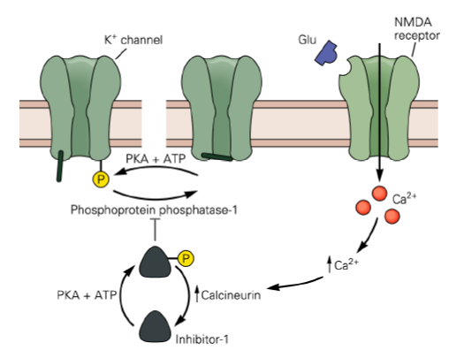
Phosphatases counteract the action of kinases
- How do proteins such as Ca/Calmodulin-dependent kinases shut down? When proteins are phosphorylated, they’re usually shut down by phosphatases.
- There are other mechanisms can inactivate a protein, e.g. ubiquitination leads to degradation/modulation of a protein.
- In this case, PKA opens the K⁺ channel (Unlike earlier desensitization example, where phosphorylation closed K channels. It again goes to show that phosphorylation doesn’t always close channels)

[Figure] This diagram shows that phosphorylation and dephosphorylation of a K⁺ channel are controlled by protein kinase (i.e. PKA) and phosphatase (i.e. phosphoprotein phosphatase-1) respectively.
  - Inhibitor-1 inhibits phosphoprotein phosphatase-1
  - Calcineurin dephosphorylates Inhibitor-1
  - Overall: Increase in intracellular [Ca²⁺] through NMDA receptors activates calcineurin, which dephosphorylates Inhibitor-1; this increases phosphatase-1 activity, and results in reduced phosphorylation of K-channels.
- Note that PKA is working in 2 different places to help itself: by phosphorylating Inhibitor-1, it inactivates phosphatase, the counteractive protein, so that it can continue to phosphorylate K⁺ channels.
- Dr. Haghighi recommends reading the textbook to understand these slides in more detail than he went over in class.

